1.Implement of the R script using a group of 12 sales price records has been sorted as follows: 5, 10, 11, 13, 15, 35, 50, 55, 72, 92, 204, 215. Partition them into three bins by each of the following methods. (a) equal-frequency (equi depth) partitioning (b) equal-width partitioning (c) clustering

# Sales data
sales <- c(5,10,11,13,15,35,50,55,72,92,204,215)
n <- length(sales)
k <- 3
size <- n / k

equal_freq <- rep(1:k, each = size)
data.frame(Sales = sales, Equal_Frequency_Bin = equal_freq)
equal_width <- cut(sales, breaks = 3, labels = 1:3, include.lowest = TRUE)
data.frame(Sales = sales, Equal_Width_Bin = equal_width)
set.seed(1)
cluster <- kmeans(sales, centers = 3)$cluster
data.frame(Sales = sales, Cluster = cluster)

output:

Sales Equal_Frequency_Bin
1 5 1
2 10 1
3 11 1
4 13 1
5 15 2
6 35 2
7 50 2
8 55 2
9 72 3
10 92 3
11 204 3
12 215 3
> # (b) Equal-Width
1 5 1
2 10 1
3 11 1
4 13 1
5 15 1
6 35 1
7 50 1
8 55 1
9 72 1
10 92 2
11 204 3
12 215 3
> # (c) Clustering (K-Means)
Sales Cluster
1 5 2
2 10 2
3 11 2
4 13 2
5 15 2
6 35 2
7 50 3
8 55 3
9 72 3
10 92 3
11 204 1
12 215 1

3. 3. Implement using WEKA for the given Apply Apriori Algorithm for given database below Assume Min_sup=2
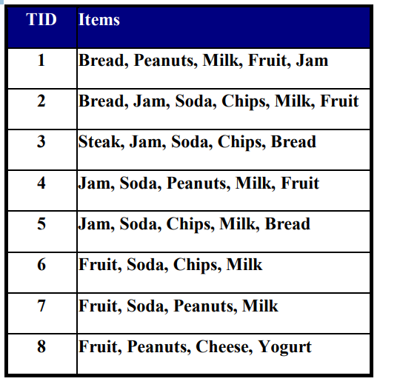

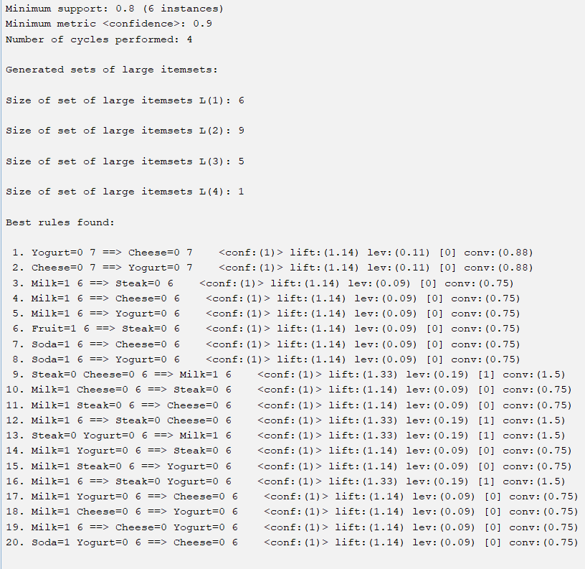

4. Use following group of data: 200, 300, 400, 600, 1000 (a) min-max normalization by setting min = 0 and max = 1 (b) (b) z-score normalization (c) (c) z-score normalization using the mean absolute deviation instead of standard deviation (d) normalization by decimal scaling

# Data
x <- c(200, 300, 400, 600, 1000)
min_max <- (x - min(x)) / (max(x) - min(x))
cat("Min-Max Normalization:\n")
print(min_max)
z_score <- (x - mean(x)) / sd(x)
cat("\nZ-Score Normalization:\n")
print(z_score)
mad_value <- mean(abs(x - mean(x)))
z_mad <- (x - mean(x)) / mad_value
cat("\nZ-Score using Mean Absolute Deviation:\n")
print(z_mad)
j <- ceiling(log10(max(abs(x))))
decimal_scaling <- x / (10^j)
cat("\nDecimal Scaling Normalization:\n")
print(decimal_scaling)

output: min_max
[1] 0.000 0.125 0.250 0.500 1.000
> Z-Score Normalization:
[1] -0.9486833 -0.6324555 -0.3162278 0.3162278 1.5811388
> # (c) Z-Score using Mean Absolute Deviation
[1] -1.2500000 -0.8333333 -0.4166667 0.4166667 2.0833333
> # (d) Decimal Scaling Normalization
[1] 0.2 0.3 0.4 0.6 1.0

5) Implement using R language in which age group of people are affected byblood pressure based on the diabetes dataset show it using scatterplot and bar chart (that is BloodPressure vs Age using dataset “diabetes.csv”)

data <- read.csv("C:/Users/Indu/Downloads/diabetes.csv")

plot(
data$Age,
data$BloodPressure,
main = "Blood Pressure vs Age",
xlab = "Age",
ylab = "Blood Pressure",
pch = 19
)

age_group <- cut(
data$Age,
breaks = c(0, 20, 40, 60, 100),
labels = c("0-20", "21-40", "41-60", "60+")
)

avg_bp <- tapply(data$BloodPressure, age_group, mean, na.rm = TRUE)

barplot(
avg_bp,
main = "Average Blood Pressure by Age Group",
xlab = "Age Group",
ylab = "Average Blood Pressure"
)
OUTPUT:
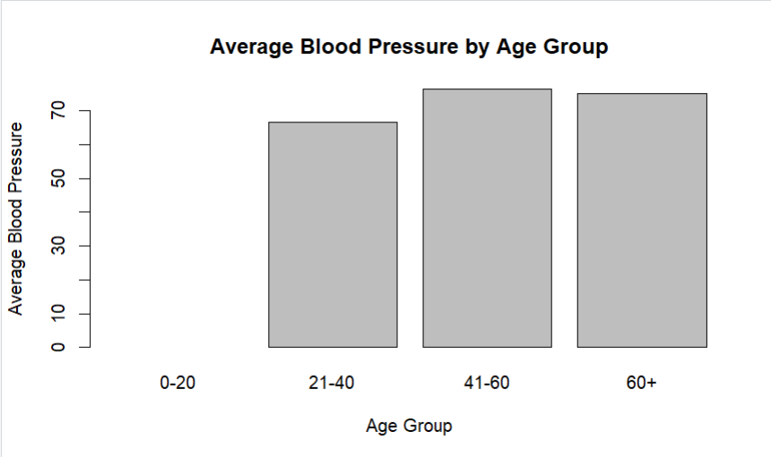

9) . Suppose that the data for analysis includes the attribute age. The age values for the data tuples are (in increasing order) 13, 15, 16, 16, 19, 20, 20, 21, 22, 22, 25, 25, 25, 25, 30, 33, 33, 35, 35, 35, 35, 36, 40, 45, 46, 52, 70. Can you find (roughly) the first quartile (Q1) and the third quartile (Q3) of the data?

age <- c(13,15,16,16,19,20,20,21,22,22,
25,25,25,25,30,33,33,35,35,35,
35,36,40,45,46,52,70)

age <- sort(age)

n <- length(age)

q1_pos <- (n + 1) / 4
q3_pos <- 3 * (n + 1) / 4

Q1 <- age[q1_pos]
Q3 <- age[q3_pos]

print("First Quartile (Q1):")
print(Q1)

print("Third Quartile (Q3):")
print(Q3)
OUTPUT:
"First Quartile (Q1):"
[1] 20
"Third Quartile (Q3):"
[1] 35

10) Download the Dataset "water" From R dataset Link.Find out whether there is a linear relation between attributes"mortality" and"hardness" by plot function.Fit the Data into the Linear Regression model. Predict the mortality for the hardness=88.
Code:
# Manually create the water dataset
water <- data.frame(
mortality = c(1247, 1668, 1466, 1800, 1600,
1550, 1490, 1700, 1620, 1400),
hardness = c(105, 17, 50, 30, 70,
80, 90, 25, 60, 110)
)
plot(water$hardness, water$mortality,
main = "Mortality vs Hardness",
xlab = "Hardness",
ylab = "Mortality",
pch = 19)
model <- lm(mortality ~ hardness, data = water)
# Show summary
summary(model)
# Add regression line
abline(model, col = "red", lwd = 2)
predict(model, data.frame(hardness = 88))

output:
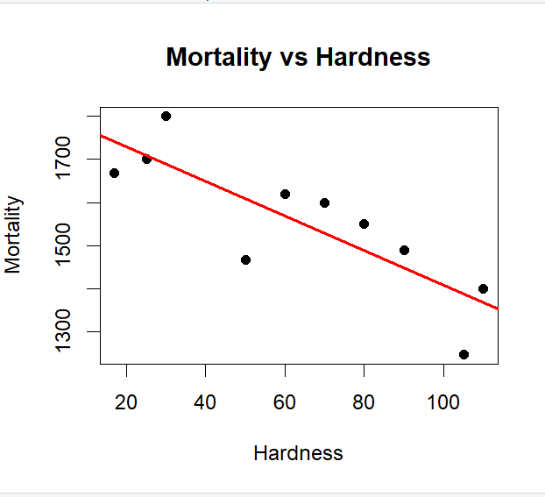

13.Imagine that you have selected data from the All Electronics data warehouse for analysis. The data set will be huge! The following data are a list of All Electronics prices for commonly sold items (rounded to the nearest dollar). The numbers have been sorted: 1, 1, 5, 5, 5, 5, 5, 8, 8, 10, 10, 10, 10, 12, 14, 14, 14, 15, 15, 15, 15, 15, 15, 18, 18, 18, 18, 18, 18, 18, 18, 20, 20, 20, 20, 20, 20, 20, 21, 21, 21, 21, 25, 25, 25, 25, 25, 28, 28, 30, 30, 30. (i) Partition the dataset using an equal-frequency partitioning method with bin equal to 3 (ii) apply data smoothing using bin means and bin boundary. (iii) Plot Histogram for the above frequency division

Code:
x <- c(1,1,5,5,5,5,5,8,8,10,10,10,10,12,14,14,14,15,15,15,15,15,15,
18,18,18,18,18,18,18,18,20,20,20,20,20,20,20,
21,21,21,21,25,25,25,25,25,28,28,30,30,30)

n <- length(x)
k <- 3
size <- n/k # equal frequency size
bin1 <- x[1:size]
bin2 <- x[(size+1):(2*size)]
bin3 <- x[(2*size+1):n]

cat("Bin 1:\n"); print(bin1)
cat("Bin 2:\n"); print(bin2)
cat("Bin 3:\n"); print(bin3)
mean1 <- mean(bin1)
mean2 <- mean(bin2)
mean3 <- mean(bin3)

smooth_mean <- c(rep(mean1, size),
rep(mean2, size),
rep(mean3, size))

cat("\nSmoothing by Bin Means:\n")
print(smooth_mean)
smooth_boundary <- function(bin) {
lower <- min(bin)
upper <- max(bin)
sapply(bin, function(v) {
if (abs(v - lower) < abs(v - upper)) lower else upper
})
}
smooth_bound <- c(smooth_boundary(bin1),
smooth_boundary(bin2),
smooth_boundary(bin3))
cat("\nSmoothing by Bin Boundary:\n")
print(smooth_bound)
hist(x,
breaks = 3,
main = "Histogram of All Electronics Prices",
xlab = "Price",
col = "lightblue",
border = "black")

OUTPUT:
(A)Bin 1:
[1] 1 1 5 5 5 5 5 8 8 10 10 10 10 12 14 14 14
Bin 2:
[1] 15 15 15 15 15 15 18 18 18 18 18 18 18 18 20 20 20
Bin 3:
[1] 20 20 20 20 21 21 21 21 25 25 25 25 25 28 28 30 30

(b)Smoothing by Bin Means:
[1] 8.058824 8.058824 8.058824 8.058824 8.058824 8.058824 8.058824 8.058824 8.058824
[10] 8.058824 8.058824 8.058824 8.058824 8.058824 8.058824 8.058824 8.058824 17.294118
[19] 17.294118 17.294118 17.294118 17.294118 17.294118 17.294118 17.294118 17.294118 17.294118
[28] 17.294118 17.294118 17.294118 17.294118 17.294118 17.294118 17.294118 23.823529 23.823529
[37] 23.823529 23.823529 23.823529 23.823529 23.823529 23.823529 23.823529 23.823529 23.823529
[46] 23.823529 23.823529 23.823529 23.823529 23.823529 23.823529
Smoothing by Bin Boundary:
> print(smooth_bound)
[1] 1 1 1 1 1 1 1 14 14 14 14 14 14 14 14 14 14 15 15 15 15 15 15 20 20 20 20 20 20 20 20
[32] 20 20 20 20 20 20 20 20 20 20 20 30 30 30 30 30 30 30 30 30
C)
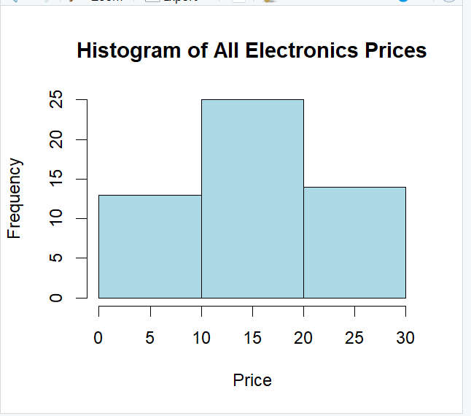

14. Two Maths teachers are comparing how their Year 9 classes performed in the end of year exams. Their results are as follows: Class A: 76, 35, 47, 64, 95, 66, 89, 36, 8476,35,47,64,95,66,89,36,84 Class B: 51, 56, 84, 60, 59, 70, 63, 66, 5051,56,84,60,59,70,63,66,50 (i) Find which class had scored higher mean, median and range. (ii) Plot above in boxplot and give the inferences
Code:
classA <- c(76, 35, 47, 64, 95, 66, 89, 36, 84)
classB <- c(51, 56, 84, 60, 59, 70, 63, 66, 50)
mean_A <- mean(classA)
median_A <- median(classA)
range_A <- max(classA) - min(classA)

mean_B <- mean(classB)
median_B <- median(classB)
range_B <- max(classB) - min(classB)

cat("Class A:\n")
cat("Mean =", mean_A, "\n")
cat("Median =", median_A, "\n")
cat("Range =", range_A, "\n\n")
cat("Class B:\n")
cat("Mean =", mean_B, "\n")
cat("Median =", median_B, "\n")
cat("Range =", range_B, "\n\n")
boxplot(classA, classB,
names = c("Class A", "Class B"),
col = c("lightblue", "lightgreen"),
main = "Comparison of Class A and Class B Scores",
ylab = "Marks")

Output:
Class A:
Mean = 65.77778
Median = 66
Range = 60

Class B:
Mean = 62.11111
Median = 60
Range = 34

17. Suppose that a hospital tested the age and body fat data for 18 randomly selected adults with the following results: (a) Calculate the mean, median, and standard deviation of age and %fat. (b) Draw the boxplots for age and %fat. (c) Draw a scatter plot and a q-q plot based on these two variables. Perform the above functions using R – tool
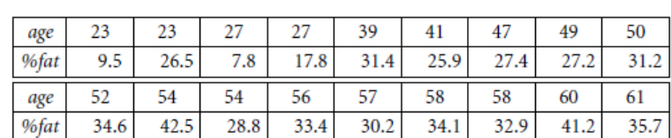

Code:
age <- c(23,23,27,27,39,41,47,49,50,
52,54,54,56,57,58,58,60,61)

fat <- c(9.5,26.5,7.8,17.8,31.4,25.9,27.4,27.2,31.2,
34.6,42.5,28.8,33.4,30.2,34.1,32.9,41.2,35.7)
cat("AGE STATISTICS\n")
cat("Mean =", mean(age), "\n")
cat("Median =", median(age), "\n")
cat("Standard Deviation =", sd(age), "\n\n")

cat("FAT STATISTICS\n")
cat("Mean =", mean(fat), "\n")
cat("Median =", median(fat), "\n")
cat("Standard Deviation =", sd(fat), "\n\n")

boxplot(age, fat,
names = c("Age", "%Fat"),
col = c("lightblue","lightgreen"),
main = "Boxplot of Age and %Fat")

plot(age, fat,
main = "Scatter Plot of Age vs %Fat",
xlab = "Age",
ylab = "% Fat",
pch = 19,
col = "blue")

# Q-Q plot for Age
qqnorm(age, main="Q-Q Plot of Age")
qqline(age, col="red")

# Q-Q plot for %Fat
qqnorm(fat, main="Q-Q Plot of %Fat")
qqline(fat, col="red")

Output:
Mean = 46.44444
Median = 51
Standard Deviation = 13.21862
Mean = 28.78333
Median = 30.7
Standard Deviation = 9.254395

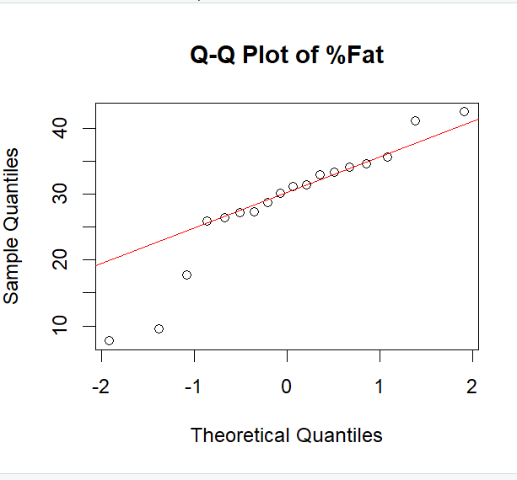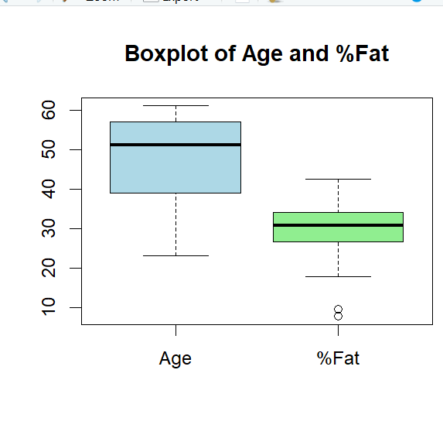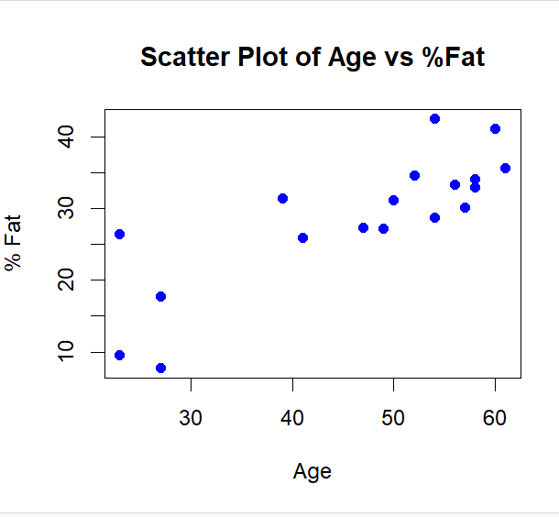

18.Suppose that a hospital tested the age and body fat data for 18 randomly selected adults with the following results: (i) Use min-max normalization to transform the value 35 for age onto the range [0.0, 1.0]. (ii) Use z-score normalization to transform the value 35 for age, where the standard deviation of age is 12.94 years. (iii) Use normalization by decimal scaling to transform the value 35 for age. Perform the above functions using R – tool

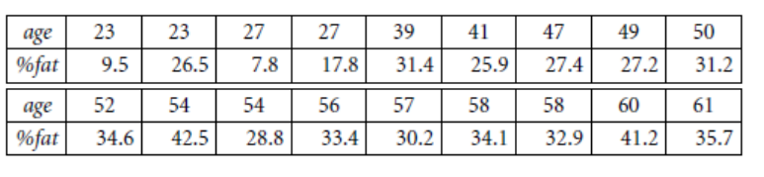
Code:
age <- c(23,23,27,27,39,41,47,49,50,
52,54,54,56,57,58,58,60,61)

value <- 35 # value to normalize

min_age <- min(age)
max_age <- max(age)

minmax_norm <- (value - min_age) / (max_age - min_age)

cat("Min-Max Normalization =", minmax_norm, "\n\n")
mean_age <- mean(age)
sd_given <- 12.94

z_score <- (value - mean_age) / sd_given

cat("Z-Score Normalization =", z_score, "\n\n")
j <- ceiling(log10(max(abs(age))))
decimal_scaling <- value / (10^j)

cat("Decimal Scaling Normalization =", decimal_scaling, "\n")
output:
Min-Max Normalization = 0.3157895
Z-Score Normalization = -0.8844238
Decimal Scaling Normalization = 0.35

19.Consider that you are owning a supermarket mall and through membership cards, you have some basic data about your customers like Customer ID, age, gender, annual income and spending score. For the above scenario, the Problem Statement was You want to understand the customers who can easily converge [Target Customers] so that the data can be given to the marketing team and plan the strategy accordingly. For the above scenario prepare a dataset and perform Clustering Analysis to segment the customers in the Mall. There are clearly Five segments of Customers based on their Annual Income and Spending Score namely Usual Customers, Priority Customers, Senior Citizen Target Customers, and Young Target Customers.Sample data
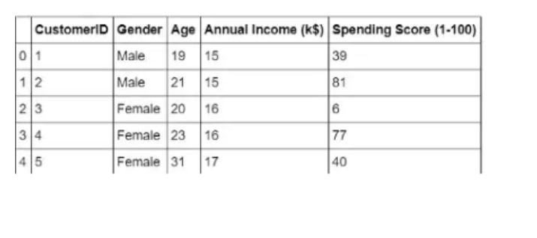

Code:
CustomerID Age AnnualIncome SpendingScore Cluster
1 1 19 15 39 5
2 2 21 15 81 2
3 3 20 16 6 4
4 4 23 16 77 2
5 5 31 17 40 5
6 6 22 18 76 2
7 7 35 40 55 1
8 8 40 42 60 1
9 9 60 20 20 4
10 10 62 19 15 4
11 11 25 70 90 3
12 12 27 72 88 3
13 13 29 75 95 3
14 14 45 60 65 1
15 15 52 58 50 1
16 16 48 65 70 1
17 17 33 45 58 1
18 18 26 50 73 1
19 19 38 55 68 1
20 20 55 30 25 4

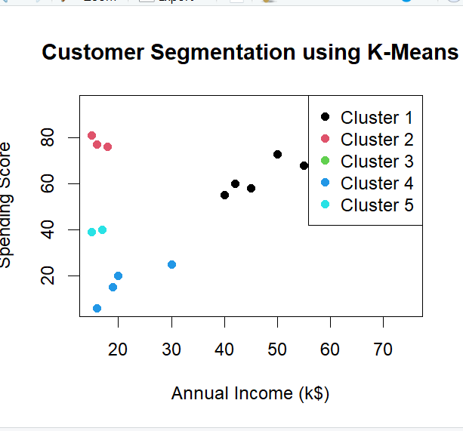

20. Streaming services often use clustering analysis to identify viewers who have similar behavior. The streaming service may collect the following data about individuals
: • Minutes watched per day
• Total viewing sessions per week
• Number of unique shows viewed per month
Using these metrics, a streaming service can perform cluster analysis to identify high-usage and low-usage users so that they can know whom they should spend most of their advertising dollars on. Apply the Hierarchical clustering algorithm and EM clustering algorithm to identify and compare the performance of the clustering technique.
Code:
stream_data <- data.frame(
MinutesPerDay = c(30,45,50,60,120,150,200,180,90,80,
20,25,35,140,160,170,55,65,75,220),
SessionsPerWeek = c(3,4,5,6,10,12,14,13,7,6,
2,3,4,11,13,15,5,6,7,16),
UniqueShowsPerMonth = c(2,3,4,5,8,10,12,11,6,5,
1,2,3,9,11,13,4,5,6,14)
)
scaled_data <- scale(stream_data)
dist_matrix <- dist(scaled_data)
hc_model <- hclust(dist_matrix, method = "ward.D")

# Plot dendrogram
plot(hc_model, main="Hierarchical Clustering")

# Cut into 2 clusters (High vs Low Usage)
hc_cluster <- cutree(hc_model, k=2)

set.seed(123)
em_cluster <- kmeans(scaled_data, centers = 2)$cluster
stream_data$Hierarchical_Cluster <- hc_cluster
stream_data$EM_Cluster <- em_cluster

print(stream_data)
table(Hierarchical = hc_cluster, EM = em_cluster)

output:

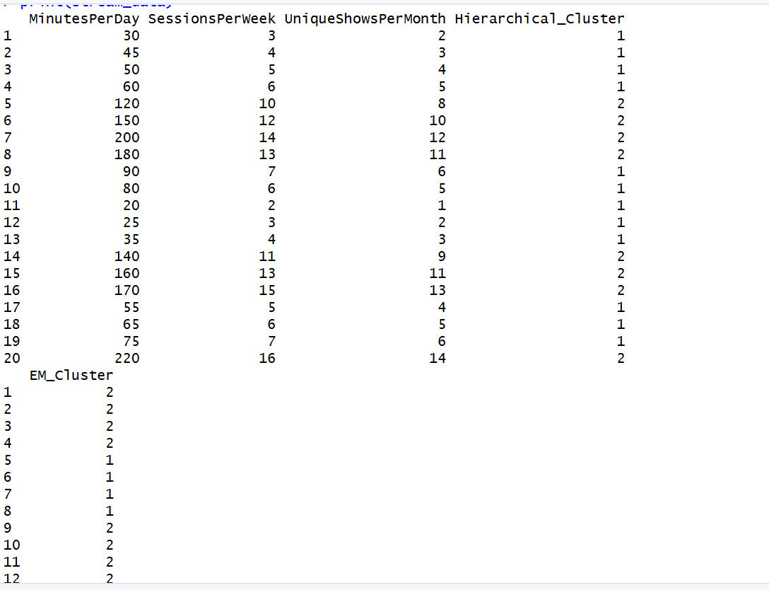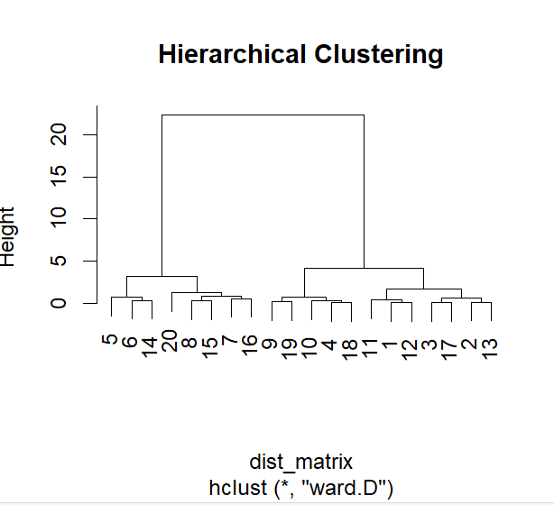

23.Create the following dataset using CSV file format. To perform cluster analysis using KMeans in WEKA. To change the cluster size and plot the graph and illustrate the visualization of cluster.
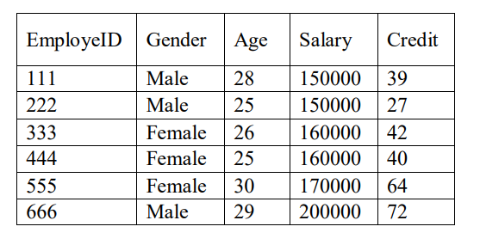

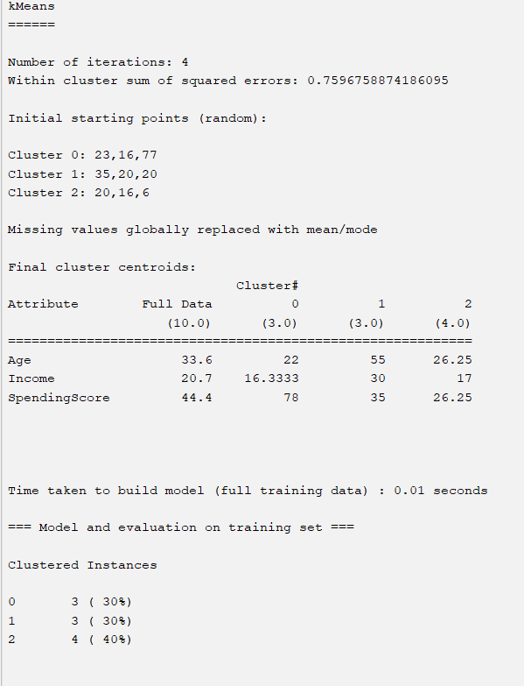

26.The following table would be plotted as (x,y) points, with the first column being the x values as number of mobile phones sold and the second column being the y values as money. To use the scatter plot for how many mobile phones sold.
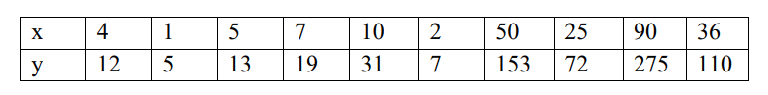

Code:
# Data
x <- c(4,1,5,7,10,2,50,25,90,36)
y <- c(12,5,13,19,31,7,153,72,275,110)

# Scatter Plot
plot(x, y,
main = "Scatter Plot: Mobile Phones Sold vs Money",
xlab = "Number of Mobile Phones Sold",
ylab = "Money Earned",
pch = 19,
col = "blue")

# Fit Linear Model
model <- lm(y ~ x)
# Add regression line
abline(model, col="red", lwd=2)
# Show summary
summary(model)
Output:
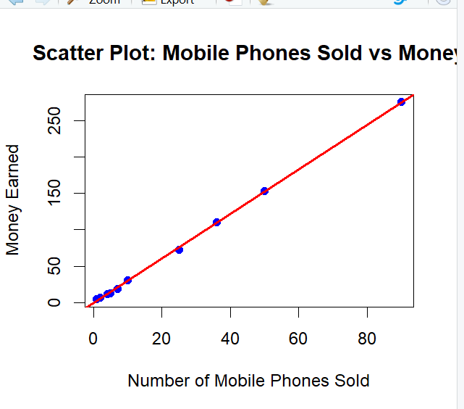

27.Generate rules using FP growth algorithm using the given dataset which has the following transactions with items purchased: Consider the values as support=50% and confidence=75%.
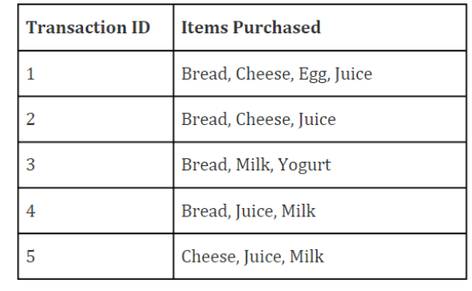

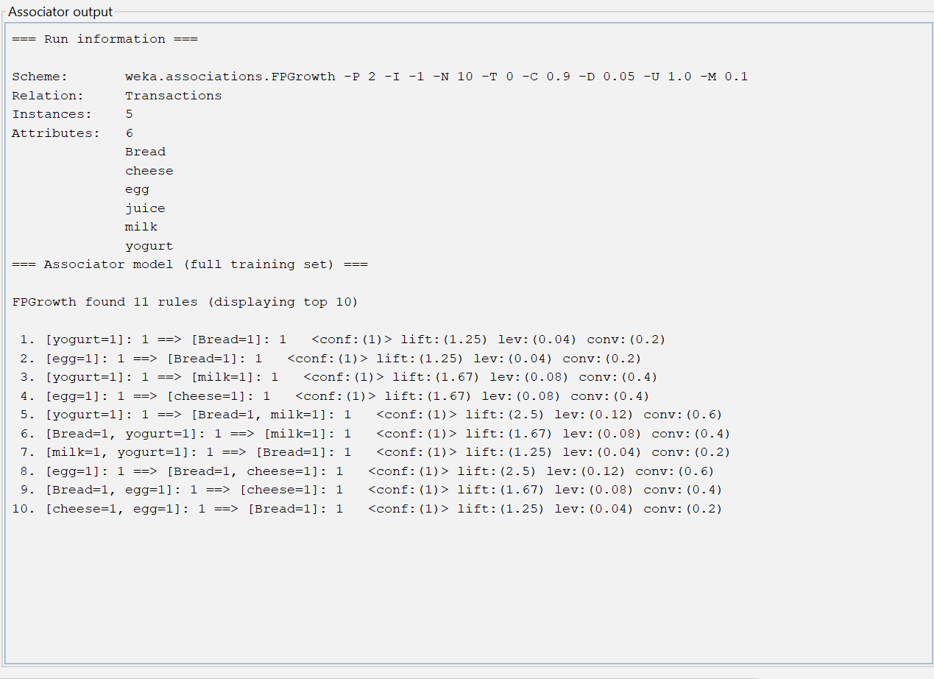

30.Consider this Decision tree : a)create the data set for the below tree using ARFF format and calculate accuracy and decision for the same b) Using this decision tree generate the rules based on rule based induction. c) Compare both the algorithms and plot the confusion matrix.
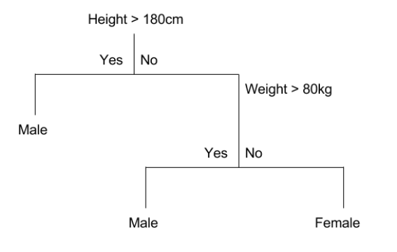
Output:
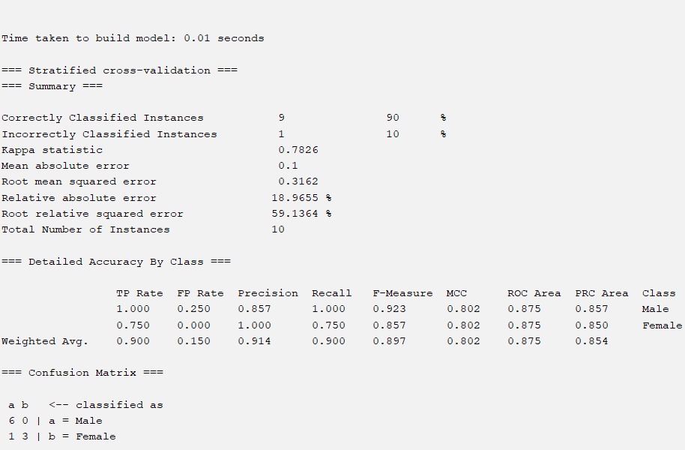

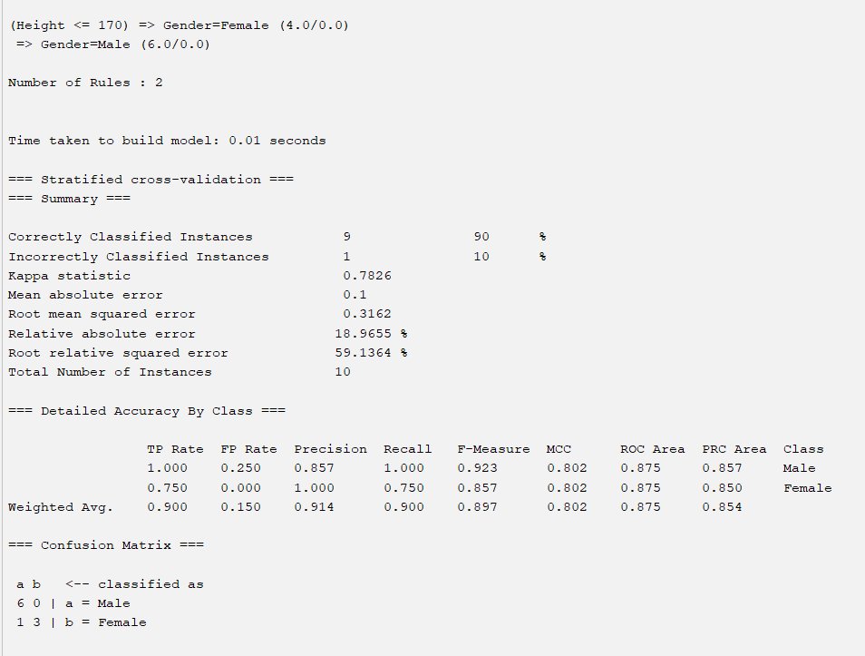

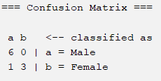

31.Create an ARFF file for the table below and implement for the Apriori Algorithm and FP growth algorithm and compare the rules generated by both the algorithms. Identify the unique rules generated by the above algorithms. NOTE: Assume Min_sup=2 and confidence= 50% 32.The given are the strike-rates scored by a batsman in season 1 in different tournaments. 100, 70, 60, 90, 90 (a) min-max normalization by setting min = 0 and max = 1 (b) z-score normalization (c) z-score normalization using the mean absolute deviation instead of standard deviation (d) normalization by decimal scaling
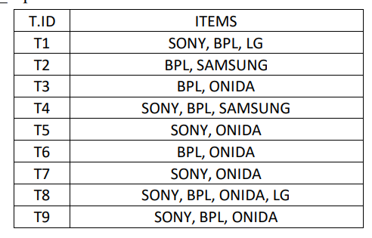

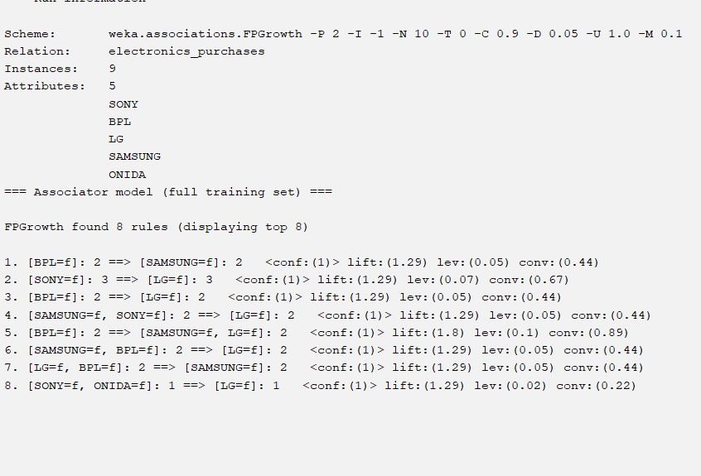

36.Create the ARFF data set for the below mentioned dataset perform the bayes theorem in addition to that compare the same with decision tree. identify the effiecient classifier with accuracy with F1 Score 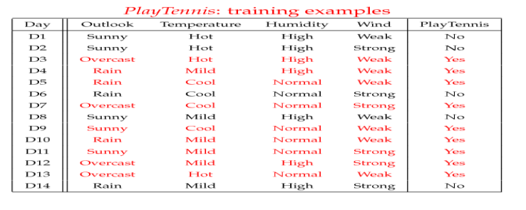
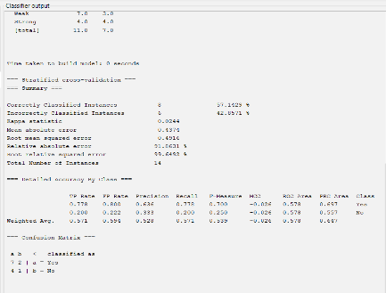

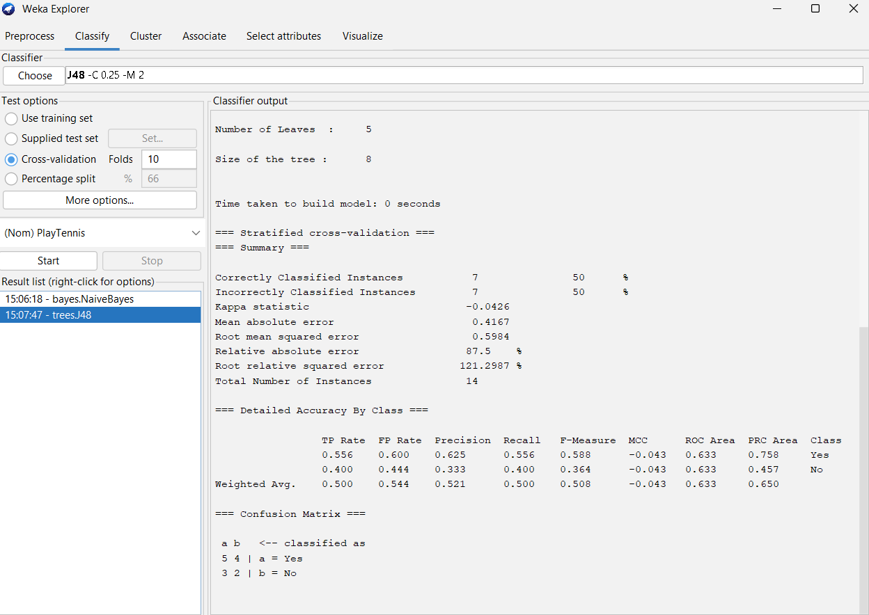

40. Suppose we want to classify potential bank customers as good creditors or bad creditors for loan applications. We have a training dataset describing past customers using the following attributes: Marital status {married, single, divorced}, Gender {male, female}, Age {[18..30[, [30..50[, [50..65[, [65+]}, Income {[10K..25K[, [25K..50K[, [50K..65K[, [65K..100K[, [100K+]}. Using Weka tool solve this problem.

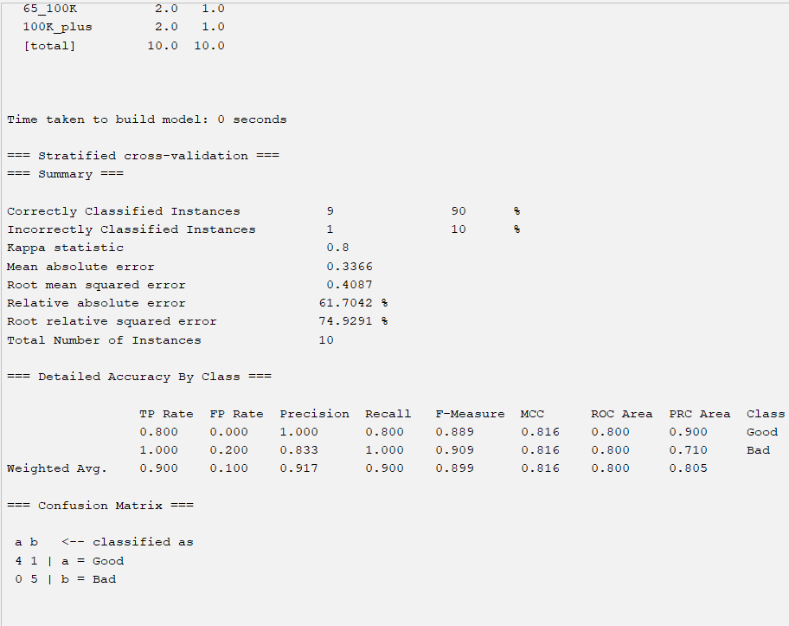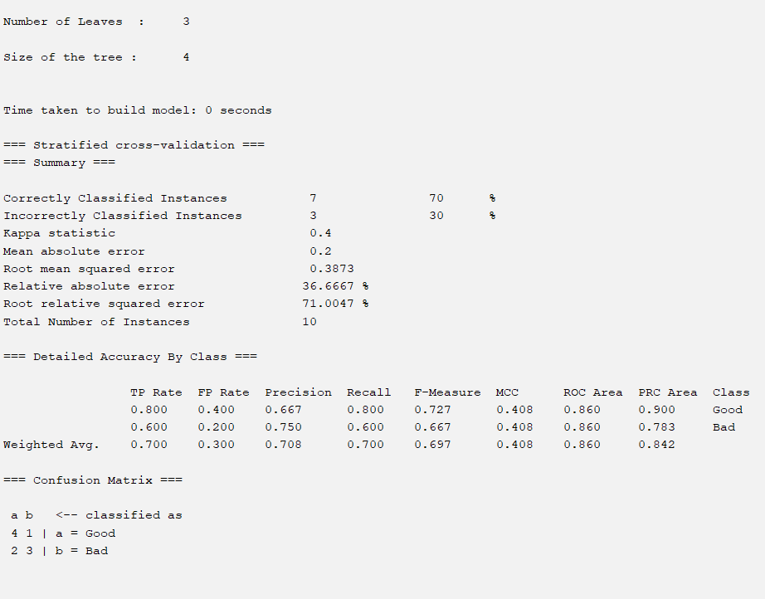

Just smooth

# Given data
data <- c(5,7,9,10,12,13,20,26,32,43,50,55,74,80)

# Sort data
data <- sort(data)

# Create bins manually
bin1 <- data[1:5]
bin2 <- data[6:10]
bin3 <- data[11:14]

# Calculate means
mean1 <- mean(bin1)
mean2 <- mean(bin2)
mean3 <- mean(bin3)

# Replace values with bin means
smooth_data <- c(rep(mean1, length(bin1)),
rep(mean2, length(bin2)),
rep(mean3, length(bin3)))

# Display result
smooth_data

